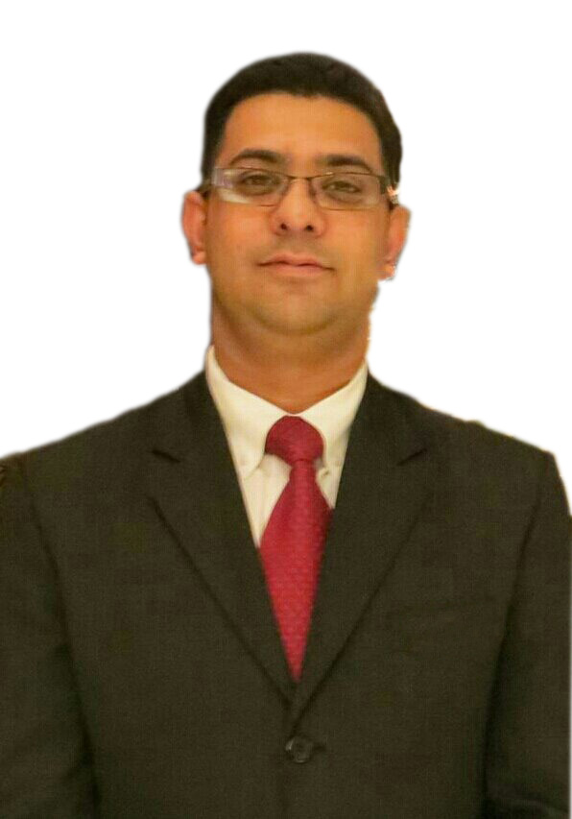

MOHAMED AKESH RISHARD
Address:193/175/1 Bandaranayekapura Mattegoda. Email: akesh.rishard@gmail.com
Mobile No. 0778507877

CAREER OBJECTIVE
My desire is to use my experience, skills, energy, knowledge and passion in a new and challenging environment while maintaining and improving all standards relating to food & Beverage service, guest satisfaction and to develop world-class standards.

educationAL CREDENTIals
Graduated General Certificate of Education O/L and A/L examination (Sri Lanka)

CAREER EXPERIENCE

Company Name : Beach Rotana Hotel Abu Dhabi, UAE
Job Title : Headwaiter (Trainee Assit Manager) (T’vic’s) 2014 May to September.

Primary Responsibilities:
- Maintain the food & beverage service to guests.
- Maintain and update all food and beverage menus and micros as directed by the Restaurant manager.
- Managing Performance, Ensure that the Restaurant operates efficiently and effectively within the Company’s operational guidelines.
- Develop guest oriented quality service and enhance guest satisfaction.Respond to guest comments and criticism in a constructive and positive manner, looking at such as an opportunity to build guest count.
- Improved guest satisfaction scores (Market Matrix, IFH)
- Carry out supervisory responsibilities in accordance with all applicable laws and regulations.
- Take restaurant bookings when required during the operational hours.
- Perform all duties associated with restaurant service, food and Beverage service. Monitor all wine storage facilities to ensure that proper storage techniques are being used and the cleanliness standards of storage areas are being maintained.
- Develop and maintain training programs.
- Develop and maintain up selling programs in association with the restaurant manager
(fine Wine)
- Develop and maintain service standards and service of sequence.
- Complete all work responsibilities and assignments in a timely manner before the specified time and date.
- Maintain an open communications with the restaurant manager. Attend and contribute to all scheduled meetings· Perform any other duties as directed.
- Reduced outlet food & beverage cost.
- Increased the sale of fine wine.
- Monitor the slow moving beverages and act accordingly.
- Supported several outlets like (Banquets,Pregos, RoomService,Bayview,Finz,Essence)during the busy operation.
- Overview knowlage of Profit and Lost.
- Maintain Hygiene Practice in Restaurant & Bar.
- Maintaining updating Learning and Development files.
- Ensures casheiring procedures caring out opening and closing reports.

Company Name : Beach Rotana Hotel Abu Dhabi, UAE
Job Title : Headwaiter (Rodeo Grill) April 2013 to April 2014.

Company Name : Beach Rotana Hotel Abu Dhabi, UAE
Job Title : Captain (Rodeo Grill) April 2012 to April 2013.

Company Name : Beach Rotana Hotel Abu Dhabi, UAE
Job Title : Waiter (Rodeo grill) March 2008 to April 2012

Company Name : Beach Rotana Hotel Abu Dhabi, UAE
Job Title : Houskeeping Attendent September 2005 to March 2008

Company Name : Golden key credit card company, Sri Lanka
Job Title : Merchant service officer February 2004 to September 2005

AWARDS & ACHIEVEMENTS

- Received the BEST STEAK HOUSE FROM TIME OUT AWARDS 2011
- Received the highest score of 95% from the mystery shopper May 2012
- Effectively organised WINE AND DINE dinner at Rodeo Grill
- Received the BEST RESTAURANT OF THE YEAR AWARD 2010 from Gourmet Abu Dhabi Awards
- Received the BEST AMERICAS RESTAURANT AWARD from the TIMEOUT AWARDS 2010
- Received the best Steak house award for Abu Dhabi in the year 2008
- Successfully supported the Abu Dhabi Gourmet chef promotion at Rodeo Grill
- Received the monthly best hygiene practice award

TRAINING AND OTHER ACHIEVEMENTS

- Opened Saffron, Silk Road Restaurants, The Beach Bar & Restaurant, Arabesque lobby café and Room service at Salalah Rotana Resort (Oman) March 2014 and make all beverage recipes.
- Opened Elements Restaurant, Hili Majlis Lobby café, sundeck pool café and Room service at Hili Rayhaan by Rotana Al Ain (U.A.E) February 2014 and make all beverage recipes.
- Opened Ginger Restaurant, Aquarius pool café and room service at Majestic Arjaan by Rotana (Bahrain) April 2013.
- Completed M.C.D (Managing Colleague Development) and working as a Departmental Trainer.
- Completed Destination Leadership training.
- Completed O.J.T (On Job Training)
- Completed basic food Hygiene training at Beach Rotana Hotel (Abu Dhabi)
- Completed Essential Food Safety training at Beach Rotana Hotel (Abu Dhabi)
- Completed first aid course at Beach Rotana Hotel (Abu Dhabi)
- Completed fire warden course at Beach Rotana Hotel (Abu Dhabi)
- Completed T.A.S.T.E training at Beach Rotana Hotel (Abu Dhabi)
- Completed Basic Beverage training at Beach Rotana Hotel (Abu Dhabi)
- Completed basic Cigar training at Beach Rotana Hotel (Abu Dhabi)
- Completed Tea training at Beach Rotana Hotel (Abu Dhabi)
- Completed WSET (level 1) wine course at Wine & spirit Education trust (Abu Dhabi)

EXPOSURE TO COMPUTERS
- MS Excel, MS Word, MS Power Point, MS Access, Internet & Its Application
- Excellent Working knowledge of Micros

personality highlights

- Well-founded fundamentals
- A Never Say Die attitude
- A Suave tongue and impressive Interpersonal Skills.

PROFESSIONAL SKILLS
- Management and Organizational Skills / Team Player and effective leadership to achieving desired goals. Effective in controlling the food and Beverage cost.
- Written and verbal Communication, Motivational and employee relations Skills.
- Problem Solving Abilities and Implement Problem Solving Initiatives.
- Ability to Prioritize Projects and Develop Time Management Strategies.
- Analyze, Develop and Implement Training Systems / Programs with SOP Manuals.
- Food & Beverage and service knowledge
- Outgoing and able to work under pressure in a busy guest environment
- Punctual & sincere in duties
- Excellent proactive attitude towards work

OTHER DETAILS

PERSONAL DETAILS
Date of Birth : 28th November 1984.
Sex : Male.
Marital Status : Married.
Nationality : Sri Lankan.
Passport No : N1421432
Permanent address : No.71, Sri Wimaladharma Rd, Badulla, Sri Lanka.
: +94552224131

Mr. John Mohan Rajan Mr. Mohamed Kamil Jainudeen
Assit Director of Food & Beverage Restaurant and Bar Manager
Khalidiya palace Rayhaan by Rotana Centro Al Manhal Rotana
Abu Dhabi (U.A.E.) Abu Dhabi (U.A.E.)
John_mohan2002@yahoo.com mkjainud@yahoo.com
John_rajan@rotana.com +971555285862.
+971505946213.

